USer Flowchart

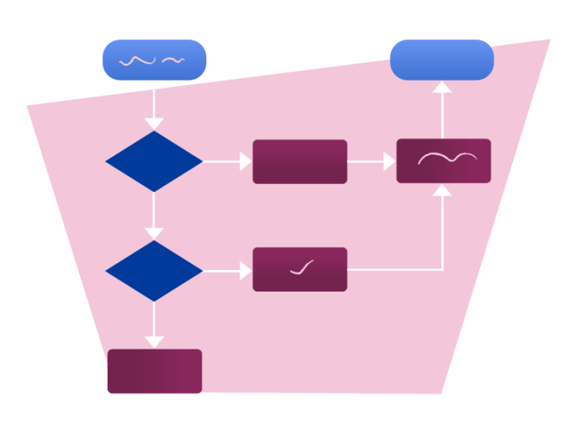

**Name: Tony Jiang**

**Project: Video call system**

**Date: 28 September 2023**

|  |  |  |
| --- | --- | --- |
| **Version** | **Date** | **Description** |
| **0.1** | **28 Sep 23** | **Initialize the document.** |
|  |  |  |
|  |  |  |
|  |  |  |

Contents

Introduction 4

User Flowchart 4

First solution 4

Second solution 5

# Introduction

This document provides a detailed explanation of the user flowchart overview of how the user interact with the system. It is designed to help identify any design flow issues and come up with solutions to improve the design flow.

# User Flowchart

The user flowchart that we are going to describe are the design solutions that have been developed. Each solution will do in detail of how it works and show the flow of the design.

## First solution

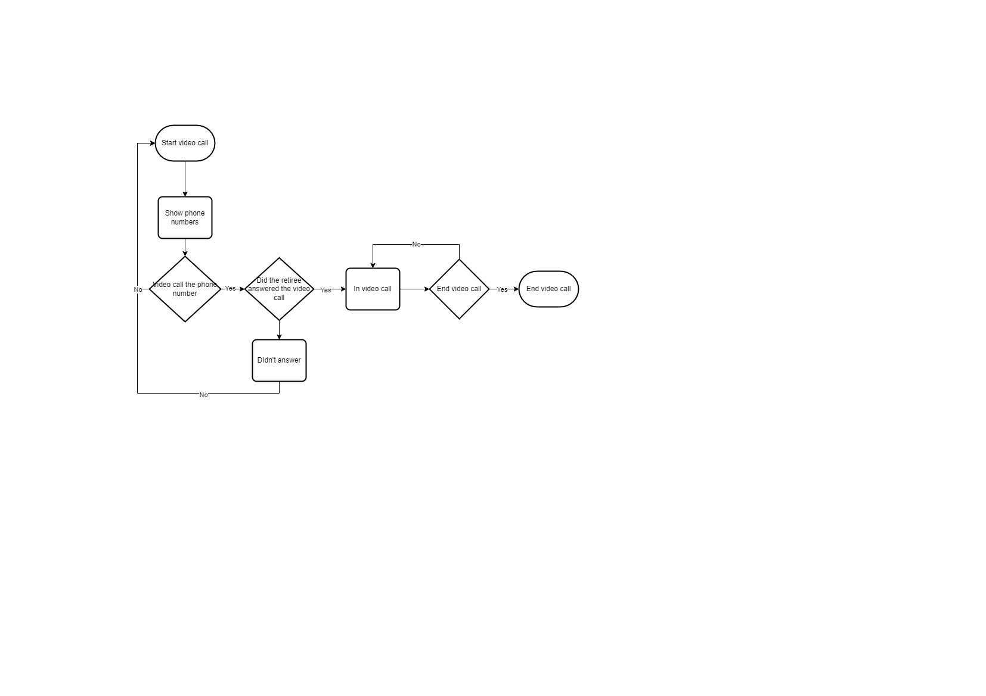

Figure : First solution

This solution describes the interaction between the SVb employee and the system. This process covers initiating and ending a video call. The flow starts when the SVb employee interacts with the “Start video call” button. Upon clicking the button, a form appears displaying two sets of phone numbers, prompting the SVb employee to select which phone number to use for the video call. These phone numbers are retrieved from the retiree's information, and displayed depended on if they have 1 or 2 phone numbers.

The SVb employee has the option to either make a video call to one of these numbers or close the form. If the form is close, the SVb employee returns to the initial “Start video call” button screen. If the SVb employee chooses to initiate a video call using one of the phone numbers, the system attempts to establish contact with the retiree.

If the retiree didn’t answer, the SVb employee returns to the starting position. However, if the retiree answers the video call, both the SVb employee and retiree are connected in a video call session. When the call needs to be concluded, the SVb employee can click the “End call” button, which triggers a confirmation message asking if they want to end the video call.

If the SVb employee selects "No," they will remain in the video call, and the message will disappear. They can repeat this process until they decide to click "Yes" to end the video call, at which point the call will terminate.

## Second solution

Figure : Second solution

This solution represents the interaction between the SVb employee and the system, covering the process from initiating the video call to ending it. While the starting point remains the same, it follows a slightly different approach.

When the SVb employee interacts with the “Start video call” button, a message box appears, asking if the SVb employee wants to initiate the video call. If the SVb employee selects "No," the message box disappears, and they return to the initial starting position. If the SVb employee chooses "Yes," the system places the SVb employee into a video meeting.

Within the meeting, the SVb employee must admit the retiree when they join the session Once the SVb employee has concluded the meeting, they can end the video call. However, before doing so, they receive a prompt asking if they want to end the video call. They have the option to select "No," which keeps them in the video call, or "Yes," which terminates the video call.